|  |
| --- |
|  |
| An Investigation Into How Different Stimuli Affect Young Drivers Reaction Times |
| A2 – Biology Coursework |
|  |
| **Ben Keppie** |
| **Long Road Sixth Form College** |

|  |
| --- |
|  |

Abstract

The purpose of this research is to find out if listening to the radio or having hands free phone call affects reaction time in young drivers. In this report there is an insight into stimuli that affect reaction times and how the body is able to respond due to a change in the environment. I found 10 participants and recorded their reaction times in three different environments: Silence, listening to a radio and taking a hands free phone call. The reaction time was measured via a computer program which was a red screen and turned green; when the screen turned green the participant had to click the screen. The time taken from the screen turning green till the click of the mouse was recorded as that participants reaction time, 5 repeats were made per participant, per environment. I had no anomalies in my results which gives me confidence that my results are reliable. I used the Mann-Whitney U statistical test to see if there was a significant difference between datasets. I found out that there was a significant difference between a silent environment and the hands free phone call as well as a difference between listening to the radio a hands free phone call; however there was no significant difference between a silent environment and listening to the radio.

Contents Page

1. **Research and Rationale**
   1. Personal Rationale
   2. Research
   3. My Aim
   4. Working Hypothesis
   5. Null Hypothesis
   6. Wider Rationale
2. **Planning**
   1. Trial Experiments & Results
   2. Statistical Test Decision
   3. Controlling Variables
   4. Equipment List
   5. Method
   6. Risk Assessment
3. **Results**
   1. Anomalies
   2. Statistical Test
   3. Interpretation and Evaluation
   4. Conclusion
4. **Evaluation of the Experiment**
5. **References**
   1. Evaluation of References
6. **Research and Rationale**
   1. Personal Rationale

My initial interest into this area of study has originated from my interest in motorcycles. What shocked me most were the statistics revolving around the cause of motorcycle crashes. The figures from 2011, in the UK alone, show that 48%[1] of crashes between motorcycles and cars were the result of the car driver failing to look properly. With a further smaller percentage of motorcycle crashes being the fault of the car driver. These statistics mean that well over 50 percent of the crashes that motorcyclists are involved in are in fact not due to the motorcyclist. Although you could argue that the accidents could be caused by the fact that motorcycles have such a high acceleration rate due to their high power to weight ratio, their decreased stability due to two wheels as well as their lack of presence on the road but you cannot ignore the statistics where car drivers are to blame.

Organisations such as THINK! (a government run motorcycle safety organisation) have produced media and advertisements including stickers to help make car drivers more aware of the presence of motorcyclists on the road.



*Figure 1 – A THINK Bike sticker.*

*[Figure 1]*

Even with an increase of awareness, after starting to ride a motorbike on the road myself, I felt I was most at risk by young car drivers, the same age as me. This then made me start to think about what could possibly be the cause of me feeling that way; the first thing I thought of was the car drivers’ environment. On a motorbike you are unable to pick up your phone and take a phone call, or fiddle around with music controls or be distracted by a passenger next to you. This invigorated me to find out more, and in turn improve my, and other people’s awareness and safety on the road.

* 1. Research

Biologically speaking about this problem, the main area of focus is reaction time; this essentially is a relationship which involves the whole body. Your eyes take in information that gets sent to the brain for processing and then you contract and relax muscles based on the information that has been processed, whether or not it has been a voluntary or involuntary response. To understand how these systems interact with each other biological background information is needed.   
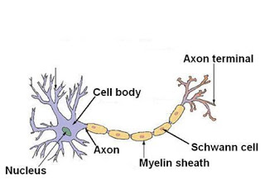

*Figure 2 – A Labelled Motor Neuron.*

*[Figure 2]*

There are many different types of neurones, and these are just nerve cells. Nerve cells and neuroglia form the tissues of the nervous system. These cells along with every other cell in the body contain a nucleus, this is the site of the synthesis of all the neuronal proteins and membranes. Some proteins are synthesised in dendrites (branched projections of a neurone that act to propagate the electrochemical stimulation received from other neural cells to the cell body) but no proteins are made in axons or axon terminals (these do not contain ribosomes.) These proteins and membranes are required to preserve the neurone cells, this is done by renewing the axon. Nerve termini are synthesised in the cell body and placed inside vesicles ready for transport. Anxoplasmic transport takes place and is responsible for the transport of the nerve proteins, movement towards the synapse is more technically known as anterograde transport. The vast majority of axonal proteins are synthesized in the neuronal cell body and transported along axons. Axonal transport occurs a lot throughout the life of a neurone as it is essential to its growth and survival. Microtubules run along the length of the axon and provide a cytoskeletal track for transportation. Kinesin and dynein are motor proteins that move the vesicles directly. Motor proteins bind and transport several different contents including mitochondria, cytoskeletal polymers and synaptic vesicles containing neurotransmitters.[2] Axonal microtubules are also the tracks along which damaged membranes and organelles move up the axon toward the cell body; this process is called retrograde transport. Lysosomes, where such material is degraded, are found only in the cell body.

Axons are specialised for the conduction of a particular type of electric impulse, called an action potential. An action potential is an electrical signal that is propagated in the plasma membrane of cells such as neurones and muscle cells, these allow for quick long-distance travelling around the nervous system. Action potentials move rapidly (up to 100 metres per second) and in humans axons can be more than a metre in length, using the speed of action potentials and the distance of the nervous system you can work out that it only takes a few milliseconds for action potential to move along their length.[3]

In complex multicellular organisms such as humans, neurons are organised into circuits. A simple example of this would be a reflex arc. Interneurons connect multiple different types of neurons allowing one sensory neuron to affect multiple motor neurons, an example where this comes into play would be the human’s response to touching a hot plate. Your muscles automatically react by contracting and relaxing to ensure that the body doesn’t touch the plate any longer.

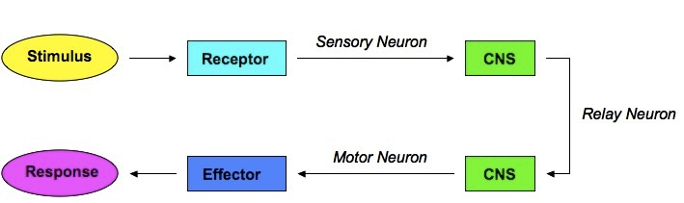

*Figure 3 – Stimulus Response Pathway. [Figure 3]*

The first event in the stimulus response pathway is a stimulus (something a human sensor receptor is able to detect) this could be sounds, contact, taste and many more. The next stage is the sensory receptor sensing the stimulus, these receptors are all over the body; however they do not all sense the same thing. For example, you have taste receptors in your mouth so you can taste food when you eat it, but when handling food with your hands you cannot taste it via hand contact. Sensory neurones then transmit information from the receptors to the central nervous system. The information received by the central nervous system is transmitted even further via relay neurones. In the example with the hot plate the information did not get processed by the brain as it was an automatic reflex, an example always involving brain processing would be visual stimuli.   
  
The brain is part of the central nervous system and the parts of the brain are complex and not fully understood. Our brain gives us awareness of ourselves and of our environment, processing a constant stream of sensory data that is received from the sensors around the body. It controls everything we do from our muscle movements to controlling chemical secretion and even our breathing and internal temperature. Every idea, sense, and procedure is developed by our brain. The brain’s neurones record the memory of every event in our lives and converting that amount of memory into a computer like file size, some people estimate out brains could hold up to 100 terabytes of storage[9].

The brain has two hemispheres which function and are responsible for very different things, for example the left hemisphere determines speech; however vision is a shared function between the hemispheres, this is able to occur as the hemispheres are connected via a corpus callosum. This wide, flat bundle of neural fibres beneath the cortex facilitates the interhemispheric communication that occurs. It is the largest white matter structure in the brain consisting of up to 250 million contralateral axonal projections. Information received from the left eye gets processed by the right hand side of the brain and information received from the right eye gets processed by the left hand side of the brain. Grey matter consists of neural cell bodies, glial cells and capillaries, in contrast to white matter.

The primary function of a brain is to control organisms actions. It does this by utilising information received from sensory organs. In order to perform these complicated tasks the brain coordinates a series of subsystems. The sensory system is the primary subsystem of the brain and extracts the information from the sensory inputs. The function of this subsystem also takes care of more complex jobs such as: Limb positioning, chemical composition of the blood stream, temperature balance and more. The motor systems are areas of the brain that activate muscle movement (as talked about earlier) to provide an organism with active movement.

The arousal system essentially modulates an individual’s sleep pattern. The Suprachiasmatic nucleus, located in the hypothalamus contains the body’s biological clock to help determine when the body needs to sleep.

Ears are the input source for hearing; they are made up of three parts: the outer ear, middle ear and inner ear. Each part of the ear plays a different role in receiving and processing sound to pass it onto the brain. The outer ear (pinna) collects the sound vibrations. The middle ear contains small bones (ossicles) that convert the sound vibrations into mechanical vibrations. The inner ear contains the organ of Corti, a sensory receptor that is inside the cochlea. These contain hair cells that are connected to nerve receptors used for hearing. Once the sound has been converted into a readable format for the brain the temporal lobe it acts as the processing centre for the information. The temporal love in the left hemisphere is responsible for hearing and comprehension and understanding of what someone is saying. In contrast to this the temporal lobe in the right hemisphere is involved in musical information and identification of different sounds.

***5) Any areas that are in conflicting use for one/some stimuli but not for others???***

As the brain undergoes such complex algorithms in order to generate an outcome some environmental stimuli cause a slower reaction time to an immediate event. Examples of this include

In the nervous system between neurones there are electrical and chemical crossings called synapses. They are not continuous throughout the body but they can still communicate with each other. This concept is derived from the fact that the nervous system is made up of discrete individual cells. Synapses are essential to the nervous system and neurones in particular as they are specialised to pass signals to individual cells. Many synapses around the body are located on an axon of the neurone; however some are located on a dendrite or soma.

Chemical synapses induce electrical activity in order to convert it into the release of a chemical (neurotransmitter) this then binds to receptors located in the plasma membrane. Due to the complexity of receptor signal induction, chemical synapses can have complex effects on the postsynaptic cell. In an electrical synapse the membranes are connected via gap junctions that are capable of passing an electrical current. This causes voltage changes in the presynaptic cell to induce voltage changes in the cell. This has an advantage over chemical synapses as it is a lot faster at transferring signals from one cell to another.

Decision making is defined as the study of identifying and choosing alternatives based on the values and preferences of the individual. In complex multi-cellular organisms decision making is a continuous process that is impacted by the interaction of the organism with the environment.

When humans react to environmental stimuli, the reaction time of that individual comes into play; however everyone’s reaction should roughly be the same. The reaction time has three main components:

- Mental Processing Time  
- Movement Time  
- Device Response Time

Mental Processing time is the time it takes for the responder to perceive that a change in environment has occurred and to decide an action to take in reaction to the change in environment. This involves four sub stages: The time taken detect the sense, the time taken to recognise the meaning of the sense, the time needed to recognize and interpret the scene and finally the time necessary to decide which if any response to make and to mentally program the movement. These four stages all come together to form the mental processing time, which eventually results in your body making a decision. Movement time would be the individuals muscle movement to take action, for example pressing the brake of a car. Finally device response time comes into play as mechanical devices take time to have an effect. For example after a driver has pressed the brake the car does not stop instantly.

The link between synapses, decision making and the physical time to respond is a complex connection through biological, chemical and an individual’s processes. These processes can be genetically programmed into an organism and then conditioned in response to the organisms environment. We've evolved to react automatically to some things; for instance the well-known 'knee-jerk' reflex, combined with other muscles, helps us to walk without needing to think about each step. Through natural selection, animals and humans with these extra survival abilities have lived to pass on their genes, whereas the ones who didn’t have these reflexes which allowed for their survival, died out.

Factors affecting reaction time are up in the thousands and can range from genetics to lifestyle factors. Caffeine is a factor which affects reaction time and is a common drug that humans come into contact with, whether that is via consuming food, like chocolate, or via drink, like tea and coffee. To a nerve cell caffeine appears to be a chemical called ‘adenosine’ when actually they have very different effects. Caffeine binds to adenosine receptors and therefore blocks adenosine from binding to them. This then has the opposite effect; caffeine causes nerve cells to speed up. Due to this increased neuron firing the pituitary gland responds to the increase in nerve cell activity and releases hormones to produce adrenaline. Adrenaline has a number of effects: pupils dilate, airways to open up, the heart to beat faster, increased blood pressure and flow, muscles tighten up and causes the liver to release sugar. [4]All of these actions result in an increased reaction time, and this is due to consumption of caffeine [5].

Time awake is a factor that has a significant effect on reaction time. When reaction time and cognitive responses were measured when participants had a small amount of time being awake, the number of errors made increased dramatically than when people were awake for a while. This could be interpreted as participants being unaware of their reduced cognitive resources and therefore tricking themselves into thinking they have the same reaction time [6]. This could also be shown by when someone has just woken up and drive to work, they will be a lot less aware and likely to react to a hazard than someone who has had lots of sleep and starts driving at midday.   
  
Gaming is a recent addition to modern society with an ever increasing number of gamers. In a study, it showed that gamers had a slight advantage when it came to reaction time [7]. This is possibly due to the games that the gamers are playing may require a quick reaction time thus giving gamers a lot of practice and time to condition their reaction time.

Due to the hemispheres of the brain it is estimated that people who are left handed have a quicker hemisphere [8]. People who undergo regular exercise are thought to have a faster reaction time [8]. Illnesses involving the respiratory system have been shown to decrease reaction time [8].

When looking into research that other scientists have done relating to my investigation I found two studies that relate to one of my stimuli each. ‘Music Effects on Drivers' Reaction Times’ by Susan Strick [15] investigates my first stimuli (listening to music) and ‘Cell phone use slows reaction time’ by William P. Berg from Miami university. [14]

From the ‘Music Effects on Drivers’ investigation the data showed that music did not have a significant effect on drivers reaction time; however for some individuals music has an effect on the reaction time. This result means that the final conclusion for this experiment is unknown. For the ‘Cell phone use slows reaction time’ the conclusion is a lot more definite. The result was a significant difference (mobile phone use slows reaction time). This experiment involved a simulation driving task, 16 young adults were each told to move their foot from the accelerator pedal to the brake as quickly as possible when they saw a red light come on. The actual results from this experiment showed that when a mobile phone was introduced to driving reaction time was slowed by 24% which is a considerable amount as at 65miles an hour that would increase stopping distance by 11 feet.

* 1. My Aim

I aim to find out whether listening to music in a car or/and taking part in a hands free phone call effects reaction time of young drivers (aged 17-18).

* 1. Working Hypothesis

Listening to music and/or taking part in a hands free phone call will have a correlation with the reaction time of a young driver. Listening to music and taking part in a hands free phone call gives a slower reaction time. To see if there is a significant difference to my data sets I am going to use a Mann-Whitney U Test.

* 1. Null Hypothesis

There will be no affect to a young drivers reaction time when an environmental stimuli is introduced (listening to the radio and taking part in a hands free phone call).

* 1. Wider Rationale

The wider applications and aim of my investigation could lead to others becoming more aware of their environment whilst driving, and therefore it is possible that my research could potentially make roads a safer place to be for all users. This is possible as it could shine light upon bad habits that drivers have that could ultimately increase the likelihood of a crash.

1. **Planning**
   1. Trial Experiments & Results

**Preliminary Test #1 – Deciding The Best Program To Measure Reaction Times**

I carried out this test so that I will be able to use a program which provides reliable and valid data as well as ease of access for me (the experimenter) as well as ease of access for the participants of my experiment. To find my programs I used the search engine ‘google’ and used the top 3 rated reaction time testing programs, and from that I have decided to carry out my own research into the best program to use. I wish to find out which one of the top 3 programs is in fact the best program to use to accurately measure reaction times.

The top three programs for measuring reaction times were:

1. The Human Benchmark Program[10]
2. Sheep Dash Program[11]
3. Traffic Light Program[12]

For my preliminary test I used 5 participants for each program and took 5 repeats of each participant. I did this so that I could test the reliability and the validity of the program. From this I hypothesised that the program with the lowest average range would be the most desirable program; however if the programs drew in range values I would take into consideration the participants preference of the program. Below are tables showing the pros and cons for each individual program:

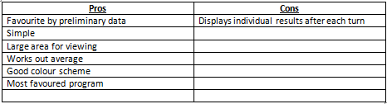Human Benchmark Program

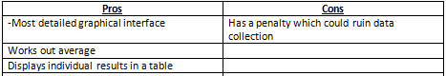Sheep Dash Program  
  
  
  
  
Traffic Light Program

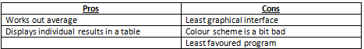

From these tables without precise data you can see that the Human benchmark Program has the most pros and the least cons whereas at the other end of the spectrum the Traffic Light Program has the least pros and the most cons. I predicted from this that the Human Benchmark Program was the program that I was more likely to use, and the program that was going to get the best results.  
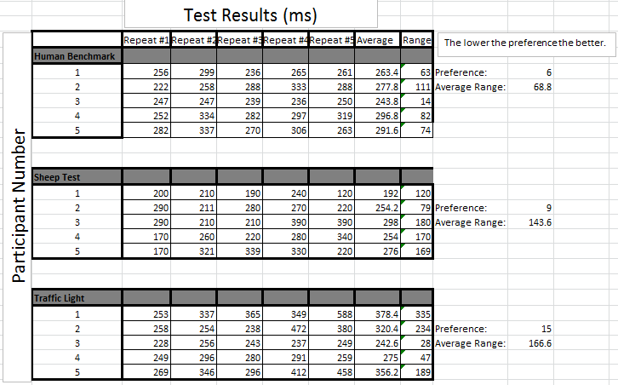My experiment results are shown above. From this I can depict that not only does the program with the lowest range of values (thus giving the most reliable results) but the participants also prefer the programs in the same order. From this I can see that my original prediction for the best program was correct, and the human benchmark program is in fact the best program to use due to it producing the most reliable data (Lowest range, 68.8 in comparison to 143.6 and 166.6).

**Preliminary Test #2 – Does Gender Affect Reaction Time?**

For my second preliminary experiment I decided to start narrowing down my variables by starting to test certain factors. Seeing as the human population is derived by the chance (50%) of offspring being male and female, it seems reasonable to test this to see if in fact there is any difference between reaction times of male or female humans. I will be testing 5 individual males and females using the program that I’m using for my final experiment (Human benchmark program) as I decided which program I am using in the previous trial. Again I will be using 5 repeats to work out the average and range of the reaction time. I hope that this preliminary test will give me a clear/no distinction as to the reliability of reaction times between males and females. If there is a clear distinction between range and average reaction time, in my final experiment I will have to control the gender of my participants in order to get the most accurate and reliable data.

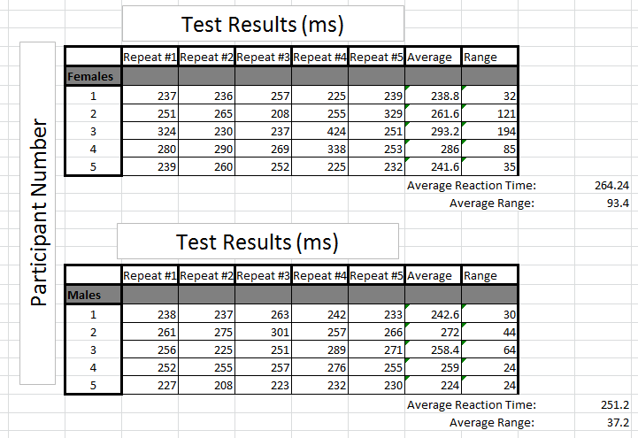

This preliminary experiment suggests that males have a faster reaction time and also that males have a more similar reaction time to each other compared to female individuals. Due to my results I will have to control gender as a variable.

**Preliminary Test #3 – Does Smoking Affect Reaction Time?**

My second preliminary test will be a comparison between smokers and non-smokers and their reaction times. I will be testing 5 individual smokers and non-smokers using the program that I’m using for my final experiment as decided in preliminary experiment 1. I hope that this preliminary test will give me a clear/no distinction as to the reliability of reaction times between smokers and non-smokers. If there is a clear distinction between range and average reaction time, in my final experiment I will have to control the lifestyle factor of smoking in my participants in order to get the most valid and reliable data. For my experiment I defined a smoker as an individual who smoked one or more cigarette a day.

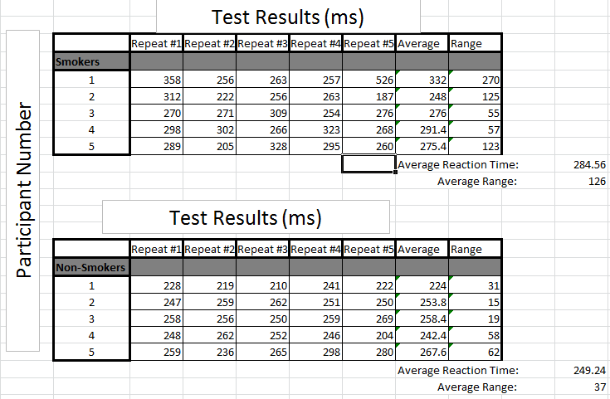Unfortunately I will not be able to measure the immediate effect of smoking on reaction times as our college and its surrounding area is a no-smoking site. Therefore my data reflects individuals that have had a cigarette in the past hour of taking the reaction test.

This preliminary experiment suggests that non-smokers have a faster reaction time and also that they have a more similar reaction time to each other as individuals compared to smoking individuals. Due to my results I will have to control smoking cigarettes as a variable.

**Preliminary Test #4 – Does Being a Gamer Affect Reaction Time?**

In this experiment I measured the how being a gamer ultimately affects reaction time, ultimately my prediction would be that PC gamers would have the fastest reaction time due to the ease of use of the mouse and the fact that they regularly use the mouse. Followed by console gamers and then followed by non-gamers. I defined the individuals as ‘gamers’ by playing on the device for an hour or longer every day, if the participant didn’t play on either for longer than an hour each day they are classified as a non-gamer. From this experiment I wished to find out whether playing games regularly on a specific console would affect reaction time, and if it did then I would have to control whether my participants for my final experiment were gamers or not.

For my experiment I took 5 repeats of each participant. Unfortunately in the sample of participants available to use, only 2 were classified as ‘PC gamers’ and only 4 were classified as ‘Console gamers’ compared to my usual use of 5 participants. I acknowledge that this may affect the validity of my results.

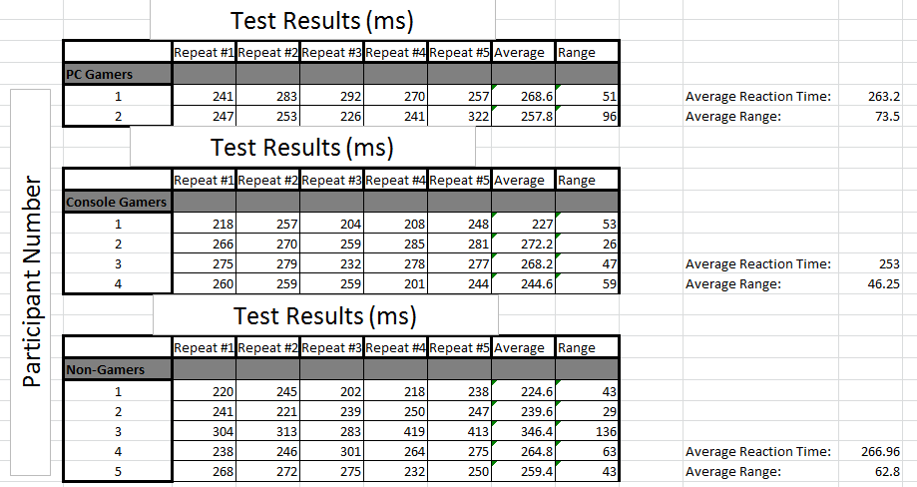  
My data for this experiment shows that in contrast to my prediction, console gamers were faster than PC gamers (by 10.2ms) and had less variation in the reaction time results; however my prediction of non-gamers was correct as they were the slowest. My data also shows that there is no significant difference between the results of Gamers and Non-Gamers as all the data overlaps. *Will insert range bars here to show, I would like to do this by hand so I’d like graph paper please. ☺*

**Preliminary Test #5 – Does Being Left/Right Handed Affect Reaction Time?**

I decided to test out how being left or right handed affected reaction time as apparently being left handed gives you an advantage over reaction time due to interactions with the left hemisphere of the brain[13].I was sceptical of this so I decided to test this out myself to see if this holds true.

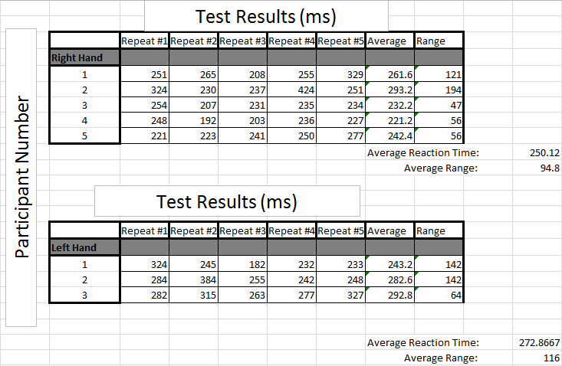I defined a person as left handed by asking them if they used the left hand for the majority of tasks, and also asked them to use the mouse with their left hand. I could easily find 5 participants that used their right hand; however I could only find 3 participants that used their left hand. I understand that this may affect the reliability of my results. I used 5 repeats for each participant and calculated the average reaction time and the average range.  
Contrary to what I had researched my data shows that in fact right handed people are faster in this sample of people and also have a lower range. This difference in reaction time is not a significant difference and therefore I will not be controlling left handed and right handed people.

* 1. Statistical Test Decision

For my statistical test I have chosen to use the Mann-Whitney U test as it will tell me whether the medians of two sets of data are significantly different from each other. As my data is unmatched this method is the most appropriate. It does not require that the data are normally distributed but it does require that both datasets are the same shape.

* 1. Controlling Variables

From my preliminary results and my independent research I found that I would need to control some variables in order to get reliable and accurate results. In order to do this I decided to create a questionnaire for a large sample to fill in. From this I would use the people that fitted the criteria. My questionnaire is shown below. 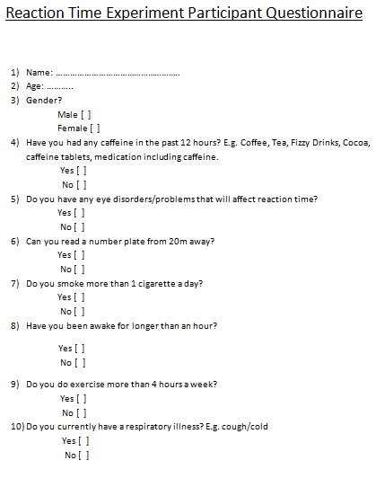

My questionnaire allowed for my participants to not have an unfair advantage/disadvantage to other participants reaction time. From my questionnaire you can see the variables that I controlled were:

* Age.
* Gender.
* Caffeine Consumption.
* Eye Disorders/Problems.
* If They’re Eligible to Drive.
* Cigarette Smoking.
* Time Awake.
* Exercise.
* Respiratory Illnesses .

My research and preliminary experiments back up my decision to control these variables.

* 1. Equipment List
* Computer with internet connection
* Mouse
  1. Method

1. Load up the program (Human benchmark reaction times)
2. Click on the red screen
3. When the red screen turns green, click the screen again
4. Repeat steps 1-3 five times with each of the 10 participants
   1. Risk Assessment

|  |  |  |  |  |  |  |  |
| --- | --- | --- | --- | --- | --- | --- | --- |
| **Activity** | **Hazard** | **Persons in danger** | **Severity (A)**  **1-5** | **Probability (B)**  **1-5** | **Risk Value**  **(A x B)** | **Measures / Comments to reduce risk** | **Risk (10 max)** |
| Listening to music | Music being too loud | Participant | 1 | 1 | 1 | I will check the volume before asking the participant to listen to any audio. | 1 |
| Using computer | Eye/Wrist strain from prolonged activity | participant | 2 | 1 | 2 | The user will not be on the computer long enough for this to occur. | 1 |
| Computer Chair | Could Cause a back injury | Participant | 2 | 1 | 2 | The user will not be sitting for a long enough period of time for this to occur. | 1 |
| Electrical Devices. | Electrocution | Participant/experimenter | 4 | 1 | 4 | Plugs will be out of anyone’s reach and therefore it would be unlikely any contact/defect will occur. | 2 |

1. **Results**

My experiment includes 10 participants that each undergo the reaction time program under 3 different environments (silent, listening to the radio and talking on a hands free phone call) the reaction time is measured at 5 different points during the experiment. The reaction time is measured by how long the participant takes to visually take in a change of the colour on the screen and click a button on the mouse. The results are shown below:



**Reaction Time (ms)**



**Participant No.**



**Reaction Time (ms)**

**Participant No.**



**Reaction Time (ms)**



**Participant No.**

* 1. Anomalies

To work out if any of my results are anomalous I am using mean +/- 2 standard deviations as this is a recognised mathematical method to identifying anomalies accurately. Data outside this range is considered anomalous. I used the population standard deviation method as I was using my whole data set in the calculation. Therefore I used the formula:

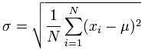

None of my results were deemed anomalous via standard deviation. I used the 5 repeats per each participant to calculate the standard deviation for all 30 data sets.

An example of using this formula is shown below for the silent table, participant number 4:



Therefore the maximum/minimum value is the mean (246.4) +/- 2 multiplied by the standard deviation (27.49982)

Maximum Value = 246.4 + 54.99964 = 301.39964  
Minimum Value = 246.4 – 54.99964 = 191.40036  
  
Any results above the maximum value or below the minimum value are anomalies, but as the maximum number from the data set is 289 and the minimum number is 214 all of the results collected are not anomalies. This held true for all 30 calculations that I did. This suggests that my data is reliable as none of them are anomalous and this therefore gives me confidence in my data.

* 1. Statistical Test

For my statistical test I have chosen to use the Mann-Whitney U test for reasons stated in my planning section (2.2). I will carry out 3 statistical tests comparing:

* Silent Environment and Listening to the Radio
* Silent Environment and a Hands Free Phone Call
* Listening to the Radio and a Hands Free Phone Call

I will use the averages for each participant as values for the statistical test. I will be carrying out my statistical test to a significance level of 0.05. Additionally I will be using a two-tailed hypothesis as I’m testing the data in both decreasing and increasing values.

To carry out the Mann-Whitney U test you follow a series of steps, these are displayed below:

1. Work out the median for each data set.
2. Put all data in order from smallest to largest and assign a rank (lowest value=Rank 1). If multiple data pieces share the same value then add up the ranks and divide by the number of data pieces and that rank is the number for each repeating value.
3. Add up the ranks for each set of data.
4. Calculate the U value for each data set using the formula: 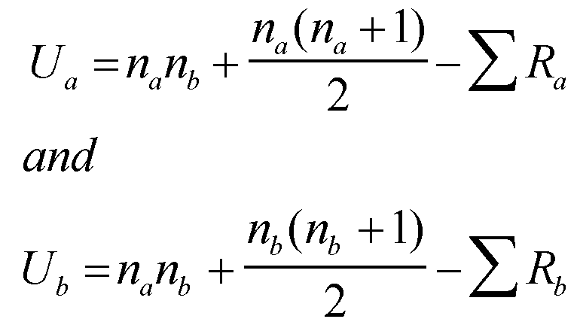
5. If the u value is less than or equal to the critical value we reject the null hypothesis.

For each experiment I have compared the results and the statistical test results are shown below.

**Silent Environment and Listening to the Radio**

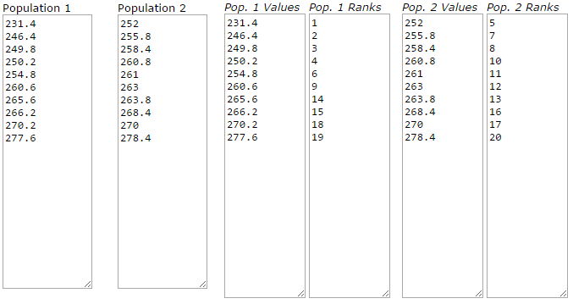

.0

.0

.0

.0

.0

.0

.0

.0

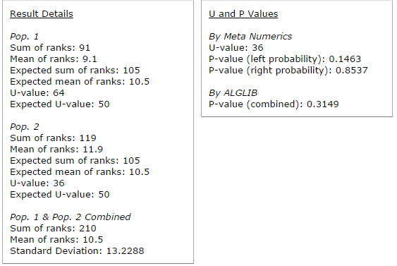

The U-value is 36. The critical value of U at p≤ 0.05 is 23. Therefore, the result is not significant at p≤ 0.05. This means that we accept the null hypothesis.

**Silent Environment and a Hands Free Phone Call**

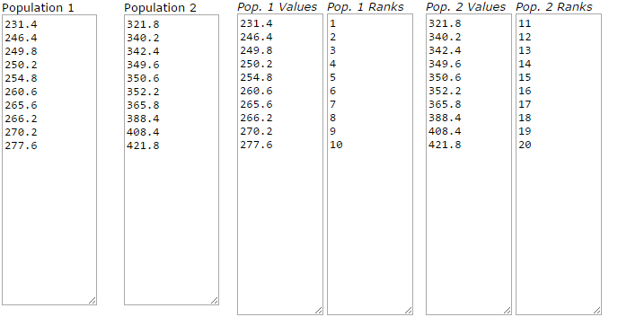 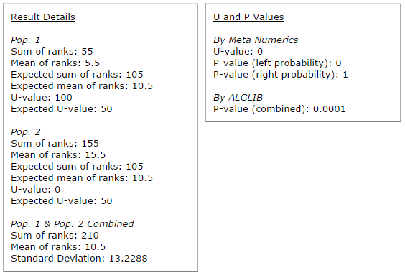

The U-value is 0. The critical value of U at p≤ 0.05 is 23. Therefore, the result is significant at p≤ 0.05. This means we reject the null hypothesis.

**Listening to the Radio and a Hands Free Phone Call**

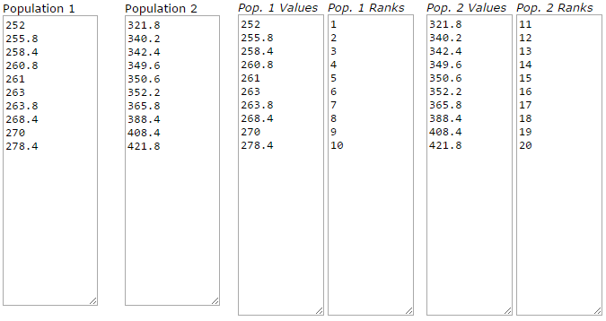 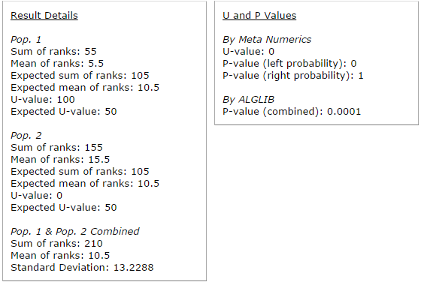

The U-value is 0. The critical value of U at p≤ 0.05 is 23. Therefore, the result is significant at p≤ 0.05. This means that we reject the null hypothesis.

* 1. Interpretation and Evaluation

My data shows that listening to the radio has no significant effect on reaction time in comparison to being in a silent environment; however being involved in a hands free phone call has a significant impact on reaction time. When comparing my results to the Human Benchmark results[16] (With results of 13,171,309 repeats), I found out that the average reaction time is 256ms; however a lot of these results are not reliable as some people click the screen repeatedly to obtain a false result of 0ms. This could explain why that average is lower than the average reaction time of my data sets, but the average is close and using a statistical test, the data isn’t significantly different. This gives me further confidence in my results as an experiment with an extremely large data set and a variety of participants gives a result that doesn’t have a significant difference to my results.

* 1. Conclusion

In conclusion my experiment has shown that with the participants in my experiment there was not a significant difference in reaction time between being in a silent environment and listening to the radio. However being involved in a hands free phone call impacts the reaction time of both listening to the radio and being in a silent environment significantly. This suggests that using your phone whilst driving makes your reaction time much slower. In conclusion from this experiment, it would be advisable to not use your phone whilst driving, as this decrease in reaction time could ultimately lead to an accident.

1. **Evaluation of the Experiment**

My experiment had no anomalous data so that leads me to believe that my data was reliable. The fact that the data showed a uniformed pattern throughout repeats and different participants I think my data was also accurate. I feel that my experiment did have limitations though, to overcome these next time I would use more repeats as I only chose to do 5 repeats which I feel, although sufficient, is not a solid convincing number of repeats. I would also chose to have a lot more participants from a larger population size as I was limited to teenagers in my college. I would then be able to see if there was a significant difference between how people from different areas are impacted by different stimuli.

Screen lag time is probably the factor most affecting my experiments accurate, newer operating systems tend to do more expensive visual effects, which means a longer lag time from the test to the screen. 30ms is currently a typical lag for a desktop, which means theoretically people’s reaction time to a real life situation will be 30ms quicker. For an improved experiment I would take away the desktop lag from the result obtained from the program.

1. **References**
   1. Evaluation of References

**References**

Source 1 – Motorcycle Statistics - **http://www.bikelawyer.co.uk/bike-accident-statistics** - Accessed 12:10, 13th September 2014

*[Scientific Journal]* Source 2 – Axoplasmic Transport and Neuronal Responses to Injury - **Cowie R.J. and Stanton G.B. "Axoplasmic Transport and Neuronal Responses to Injury." Howard University College of Medicine** – Accessed 15:53, 15th September 2014

Source 3 - **http://www.ncbi.nlm.nih.gov/books/NBK21535/** - Accessed 18:32, 15th September 2014

Source 4 – How Caffeine Works - **http://www.science.howstuffworks.com/caffeine4.htm** – Accessed 17:23, 16th September 2014

*[Scientific Journal]* Source 5 – Caffeine does increase reaction speed - **Jacobson, Bert H.; Edgley, Betty M. “Effects of caffeine in simple reaction time and movement time.” Aviation, Space, and Environmental Medicine, Vol 58(12), Dec 1987, 1153-1156.** Accessed 17:26, 16th September 2014

*[Scientific Journal]* Source 6 – Time awake and its effect on reaction time – **Marc Pomplun, Edward J. Silva, Joseph M. Ronda, Sean W. Cain, Mirjam Y. Much, Charles A. Czeisler and Jeanne F. Duffy “The effects of circadian phase, time awake, and imposed sleep restriction on performing complex visual tasks: Evidence from comparative visual search.”** Accessed 16:22, 17th September 2014

*[Scientific Journal]* Source 7 – Gamers and reaction time – **Kwan Min Lee, Wei Peng.** **“What do we know about the social and psychological effects of computer games?”** Accessed 15:43, 18th September 2014

Source 8 – List of factors that affect reaction time - **biae.clemson.edu/bpc/bp/lab/110/reaction.htm** – Accessed 16:21, 18th September 2014

Source 9 – Brain Storage Space - **http://www.slate.com/articles/health_and_science/explainer/2012/04/north_korea_s_2_mb_of_knowledge_taunt_how_many_megabytes_does_the_human_brain_hold_.html** - Accessed 17:10, 5th October 2014

Source 10 – Human Benchmark Program - **www.humanbenchmark.com/tests/reactiontime** - Accessed 20:37, 5th October 2014

Source 11 – Sheep Dash Program -**http://www.bbc.co.uk/science/humanbody/sleep/sheep/reaction_version5.swf –** Accessed 20:38, 5th October 2014

Source 12 – Traffic Light Program - **https://faculty.washington.edu/chudler/java/redgreen.html** - Accessed 20:39, 5th October 2014

*[Scientific Journal]* Source 13 – Cerebral Dominance - **Myfanwy Kerr, Rosemary Mingay and Alick Elithorn “Cerebral Dominance In Reaction Response Times” British Journal of Psychology, Volume 54, Issue 4** – Accessed 21:36 6th October 2014

Source 14 – Cell phone experiment - **http://miamioh.edu/news/article/view/2859 -** Accessed 11:40, 20th October 2014

Source 15 – Music Experiment - **http://www.drdriving.org/misc/music_strick_report.html** - Accessed 11:45, 20th October 2014

Source 16 – Human Benchmark Statistics - **http://www.humanbenchmark.com/tests/reactiontime/statistics** - Accessed 15:10, 29th October 2014

**Figures**

Figure 1 – Think Bike Sticker - **http://ecx.images-amazon.com/images/I/51VpLVcxN8L._SY300_.jpg** - Accessed 12:12 13th September 2014  
  
Figure 2 – Neurone cell labelled - **http://1.bp.blogspot.com/-77bWxyPaz8Q/Tkd00_T2RkI/AAAAAAAAAgw/i736GQtvemE/s320/user1204_1144670302.JPG** - Accessed 15:42, 15th September 2014

Figure 3 – Stimulus Response Pathway - **http://www.vce.bioninja.com.au/_Media/stimulus_response_med.jpeg** - Accessed 18:40, 15th September 2014